The Wedding Day Special
Package deals
Love Bird Special | The Big Day Special | A New Beginning Special
  One | 8x10 | Cost
  Two | 5x7 | Cost
  Four | 4x6 | Cost
  Eight | 3x5 | Cost
  Ten | Wallets | $195
  One | 8x10 | Cost
  Two | 5x7 | Cost
  Four | 4x6 | Cost
  Eight | 3x5 | Cost
  Ten | Wallets | $215
  One | 8x10 | Cost
  Two | 5x7 | Cost
  Four | 4x6 | Cost
  Eight | 3x5 | Cost
  Ten | Wallets | $250
Directions: Below are three different package options. Please choose the one that you would like. Then fill out the information needed.
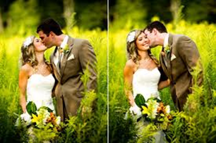

1 8x10
1 8x10
1 8x10

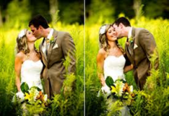


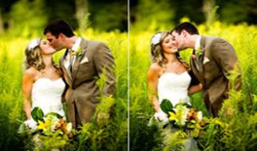

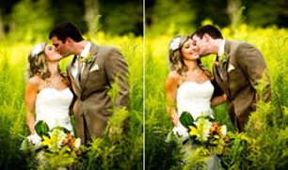
8 3x5
4 4x6
8 3x5
8 3x5
4 4x6
2 5x7
2 5x7
2 5x7

4 4x6

FULL NAME: Click here to enter text.
PACKAGE CHOICE (S): Love Bird Special ☐ the Big Day Special ☐ A New Beginning Special ☐
PAYMENT CHOICE: Cash ☐ Check☐ If chosen, Check Number# ___________ visa/master card ☐
BILLING ADDRESS: Click here to enter text. BILLING ZIPCODE: Click here to enter text.

