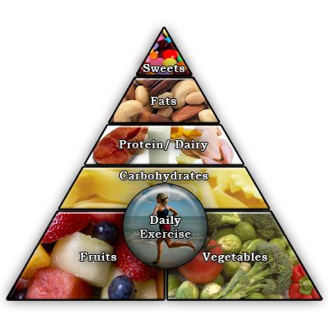
Healthy EATING
Good nutrition can lower your risk of developing a range of chronic diseases. For example, eating more fruit and vegetables can help lower blood pressure and may lower your risk of certain types of cancer (such as colorectal, breast, lung and prostate cancer). Eating less saturated fat may also lower your risk of heart disease.

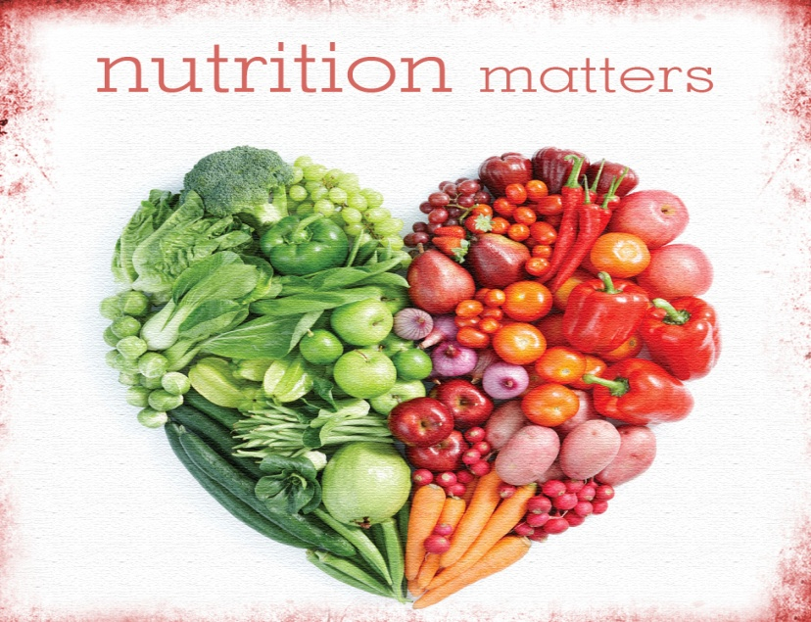
Why Eat Healthy?
A Healthy Choice
Obviously fruits and vegetables are always a good choice. But also every diet depends on age and amount of physical activity. Also it depends on the type of diet you chose to what kind of foods will best suit you.

Try to achieve a balance with the foods you eat and include lots of variety and remember all things in moderation.

Health Benefits
Healthy eating can also help people that already have some types of disease or illness such as diabetes, high cholesterol and blood pressure. And, of course, improving your eating habits will contribute to you achieving and maintaining a healthy weight.

Keep Your Body Strong
Eating a healthy, balanced diet provides nutrients to your body. These nutrients give you energy and keep your heart beating, your brain active, and your muscles working.
Nutrients also help build and strengthen bones, muscles, and tendons and also regulate body processes, such as blood pressure.
Parents and caregivers play a key role in not only making healthy choices for children and teaching children to make healthy choices for themselves.

